**CAMPAIGN ANALYSIS**

**BANK MARKETING DATA**

**Table of Contents**

Executive Summary 1

Introduction 1

Description of the dataset 2

Original Data 2

Data Preprocessing 2

Consumer Profile 4

Methodology 5

Market Basket Analysis(MBA) 5

Clustering 6

Results 7

Market Basket Analysis(MBA) 7

Clustering 9

Conclusion 11

Future Analysis 11

Appendix 12

Appendix I – Transactional variables 12

Appendix II –Demographical and Socio-Economical Features 12

Appendix III – Basket Items 13

Appendix IV – ReceiptID[Duplicates] 15

Appendix V – Value 15

Appendix VI – pmethod 17

Appendix VII – sex 18

Appendix VIII – homeown 18

Appendix IX – income 19

Appendix X – age 20

Appendix XII – parent 22

Appendix XIII – Pet Owner 22

Appendix XIV – Basket items 23

Appendix XV – Summary for Numerical Variable 23

Appendix XVI – Summary for Categorical Variable 23

Appendix XVII – Income dominating the cluster results 24

Appendix XVIII – Cluster Size 25

Appendix XIX – Number of Children across clusters 25

Appendix XX – Income across clusters 26

Appendix XXI – Value across clusters 27

Appendix XXII – Age across clusters 28

Appendix XXIII – Gender Insights across clusters 29

Appendix XXIV – Payment Methods across clusters 29

Appendix XXV – Parents Insights across clusters 30

Appendix XXVI – Homeown across clusters 30

Appendix XXVII – Pet Owner across clusters 31

Appendix XXVIII – Pet Insight across clusters 31

Appendix XXIX – 3D(Income, age & Value) Scatter plot 32

# **Executive Summary**

Finance and banking are one of the most extensive and extremely competitive markets. Any organisation going face-to-face with the big players need to fortify that they understand precisely how buyers like to interact with their sales and marketing processes. Customers today lean on both online as well as offline means to shop before deciding. Almost on every occasion, an offline phenomenon such as making a phone call or visiting a branch is a positive indicator of a possible conversion. In this report, a bank marketing dataset of a Portuguese bank is selected where the marketing campaigns were based on phone calls. The report is based on the Bank Marketing Data from [**UCI ML Repository**](https://archive.ics.uci.edu/ml/datasets/Bank+Marketing).

Initially, the dataset is split into training data, testing data and evaluation data. The data is imbalanced in terms of outcome category. SMOTE(Synthetic Minority Over-sampling TEchnique) was performed to handle the imbalance in the dataset. Various pre-processing techniques such as scaling, creating dummy variables were performed to make data suitable for modeling. The outcome of the campaign is predicted using various classification and prediction models. < ADD HERE >

# **Introduction**

Banks and financial institutions exist to offer financial services to people and to make huge profits. Having said that, banks also devote remarkable resources and business intellect to gain capital. One of the most common ways for banks to do this is to engage in direct marketing campaigns like phone calls and face-to-face meetings to promote and provide services. Phone calls, i.e. Telemarketing is a conventional marketing technique that helps to soar profits for any given business. Moreover, it also offers a more interactive and personal medium of sale service which can initiate an instant rapport with the prospective customers. Furthermore, telemarketing can help an organization to reach out more customers than with in-person or by going door-to-door and it can benefit a company to sell a product to both existing and new customers. For banking industry, telemarketing can be useful to communicate with large number of customers and offer them with all the services that they have for them. This may include information about loans, term deposits, mortgages, Overdraft facility, Credit cards etc.

For this project, a data set of a Portuguese Bank direct marketing campaign is used. This dataset is obtained from the [**UCI ML Repository**](https://archive.ics.uci.edu/ml/datasets/Bank+Marketing). The primary objective of this project is to find the best model to predict whether a customer will subscribe for a term deposit or not using various classification techniques. Our secondary objective is to determine what factors in this data set would contribute the most for the sale of term deposits to the potential customers. The target users for this project are the marketing team of a banking institution who are looking to increase their inflow of cash deposits. The following sections of this report includes the description of the dataset in detail, all the methods (classification techniques) that has been applied on the dataset to get the results and eventually the best one is described thoroughly. Moreover, the result for the best model is presented followed by conclusion which summarises the most important findings and the scope of future research is suggested.

# **Description of the dataset**

## Original Data

The original dataset used in this analysis was provided in the Comma Separated Values(.csv) format. The spreadsheet consists of:

* 45211 observations(rows)
* 17 variables(columns)
  + 4 Demographic Variables – age, job, marital, education. *[Appendix I]*
  + 4 Variables representing Economical and Socio-Economical standing of the customers – balance, default, housing, loan. *[Appendix II]*
  + 8 Variables representing campaign information – contact, day, month, duration, campaign, pdays, previous, poutcome, y. *[Appendix III]*
  + 1 Target variable – y.

The table below offers a brief description of each variable(For the detailed table go to Appendix)

|  |  |  |
| --- | --- | --- |
| **Variable** | **Type** | **Description** |
| ***age*** | Continuous | Age of the customer in years |
| ***job*** | Nominal | Type of job: “blue-collar”, “management”, “technician”, “admin”, “services”, “retired” and more |
| ***marital*** | Nominal | Marital Status: “Married”, “Divorced”, “Single” |
| ***education*** | Nominal | Level of Education: “Primary”, “Secondary”, “Tertiary”, “Unknown”. |
| ***default*** | Binary | Has credit in default? : “No”, “Yes” |
| ***balance*** | Continuous | Average yearly average, in euros. |
| ***housing*** | Binary | Has housing loan? : “No, “Yes” |
| ***loan*** | Binary | Has personal loan? : “No”, “yes” |
| ***contact*** | Nominal | Communication type : “telephone”, “cellular”, “unknown” |
| **day** | Discrete | Last contact day of the month |
| **month** | Nominal | Last contact month of the year |
| **duration** | Continuous | Last contact duration, in seconds |
| **campaign** | Continuous | Number of contacts performed during this campaign and for this client(Includes last contact) |
| **pdays** | Continuous | Number of days that passed by after the client was last contacted from a previous campaign(-1 means client was not previously contacted.) |
| **previous** | continuous | Number of contacts performed before this campaign and for this client |
| **poutcome** | Nominal | Outcome of the previous marketing campaign : “unknown”, “other”, “failure”, “success” |

***Table 1 Variable Description of Original Data***

## Data Pre-processing

The owner of the data mentioned that data is cleaned on the [**UCI ML Repository**](https://archive.ics.uci.edu/ml/datasets/Bank+Marketing).And after careful analysis the same conclusion was reached. One observation was removed from the data for having extreme value for “previous” variable.

Later in the analysis the dummy variables were created for categorical variables having more than two categories. The numerical variables were not on equal footing and the scaling was performed to adjust the variance of the variables in order to nullify the effect of the larger variables on the models. The data was split into three different subsets for training(80%), validation(10%) and testing(10%) randomly.

The outcome variable in the training data was imbalanced: 89% of the observation has “No” value for the outcome variable. This imbalance could affect the model training as model would be able to learn more about the “No” observation compared to “Yes” observations. This problem can be targeted by using over-sampling or under-sampling. I chose to do over-sampling using SMOTE because that way more data would be available to train the model. The following table has the details of all three subsets after performing the SMOTE.

|  |  |  |
| --- | --- | --- |
| **Subset** | **Observations, Features** | |
|  | **Before Pre-processing** | **After Pre-processing** |
| ***Training*** | (36168, 17) | (63758, 42) |
| ***Validation*** | (4521, 17) | (4521, 42) |
| ***Testing*** | (4522, 17) | (4522, 42) |

***Table 2 Subsets of the data***

**< ADD TABLE IN APPENDIX ABOUT VARIABLES>**

**< LIST OF FIGURES AND LIST OF TABLES >**

## Consumer Profile

Coles customers’ age range from 16 to 95 years averaging around 39 years. The median annual income is $70,170 with 50% of the customers earning between $65,623 and $75,324. There seems to be a gap between income $120,000 and $130,000 with no apparent reason that justifies it.

At least 60% of the customers are female and they spend a median amount of $68.17 per transaction, where males spend $56.72 which indicates that generally, women take care of the grocery. The median amount spent by all the customers on is around $63.28.

At least 73% of the customers own a house and they spend 16% less median value than customers who own a house and 70% of the customers are parents. Generally, customers have 1, 2 or 3 children. There are very few occurrences where customers have more than 3 children.

The payment preferences of the customers are(in descending order): Card 42.49%, EFTPOS 30.5%, Cash 14.4%.

**FUN FACT**: - Around 31%(18,076) of the total customers own a pet(s). Out of those 18,076 customers 53% own a dog(s), 37% own a cat(s) and 10% own both a dog(s) and a cat(s).

The **MOST** purchased items were: The **LEAST** purchased items were

1. Bread, 82.85% of the times 1. KitKat, 1.64% of the times

2. Milk, 81.34% of the times 2. energydrink, 1.85% of the times

3. Cereal, 76.35% of the times 3. frozen fish, 2.94% of the times

4. Banana, 76.18% of the times 4. TeaTowel, 3.70% of the times

5. Lettuce, 74.31% of the times 5. Icecream, 4.36% of the times

Find visualization related to basket items in *Appendix XIV*. All other visualizations and summary statistics can be found in the ***Appendix***.

# **Methodology**

## Market Basket Analysis(MBA)

The purpose of MBA is to discover patterns in customer purchases that could be useful to the retailer and help determine the correct stock levels, product placements on shelves, catalog design and strategy for the next marketing campaign and target audience. The most useful weapon in the data mining arsenal is generating association rules using MBA when it comes to Transactional data.

Apriori algorithm is widely used to generate association rules. These rules are generated on the basis of how frequent a product is in the data. I used package *mlxtend* in Python to generate rules. The algorithm uses the following metrics and terminology:

* **Rules**: - Given a rule "A -> C", A stands for antecedent(Item A) and C(Item C) stands for consequent.
* **Antecedent Support**: - It computes the proportion of transactions that contain the antecedent A.
* **Consequent Support**: - It computes the support for the itemset of the consequent C.
* **Support**: - Support is used to measure the frequency (often interpreted as significance or importance) of an itemset in a database(all the transactions here).
* support(A -> C) = support(A ∪ C)
* The 'support' metric then computes the support of the combined itemset A ∪ C -- '**'support' depends on 'antecedent support' and 'consequent support' via min('antecedent support', 'consequent support')**
* **Frequent Itemset**: - We refer to an itemset as a "frequent itemset" if you support is larger than a specified minimum-support threshold. Due to the downward closure property, all subsets of a frequent itemset are also frequent.
* **Confidence**: - The confidence of a rule A -> C is the probability of seeing the consequent in a transaction given that it also contains the antecedent.
* confidence(A -> C) = support(A -> C) / support(A)
* **This metric is not symmetric or directed; for instance, the confidence for A -> C is different than the confidence for C -> A.** The confidence is 1 (maximal) for a rule A->C if the consequent and antecedent always occur together.
* **Lift**: - The lift metric is commonly used to measure how much more often the antecedent and consequent of a rule A -> C occur together than we would expect if they were statistically independent.
* lift(A -> C) = confidence(A -> C) / support(C)

Before running the algorithm, we need to set threshold parameters. We set minimum antecedent support at 10%, which means that the antecedent product(or product set) must have occurred in the data at least 10% of the times. 10% threshold support seems rather low but since the data set is large (57,622 transactions), the probability of occurrence is relatively small. *[Threshold for lift has been set to 1]*

## Clustering

Cluster analysis or clustering is the task of grouping a set of objects in such a way that objects in the same group (called a cluster) are more similar (in some sense) to each other than to those in other groups (clusters). It is an unsupervised classification technique, which means that classes are not predefined. I intend to uncover the customer segmentation based on their features like spending habits, income, and age that’s why I chose clustering to analyze data.

There are many clustering techniques: Hierarchical Clustering which decomposes the data using either divisive or agglomerative strategies. Generally, they are preferred as they don’t require the number of clusters o be specified in advance. However, our data set is too big for such an algorithm and it would take a significant amount of time. So, I chose KMeans for clustering as it would be much more efficient. There are also many ways to carry out KMeans depending upon which distance metric we use to create clusters but here I’ll be using Euclidean distance.

The KMeans clustering method is a partitioning algorithm. Once we specify the number of clusters in the data set, the algorithm will randomly select a centroid for each cluster(generally points from data set), find the closest data points and assign them to the centroid, recalculate the centroid(by averaging all the data points in the cluster). The above steps are repeated until there is no change in the centroids. There are many limitations of this KMeans, one of them is this can only be applied to the continuous variable. I wanted to group customers based on age, spending, and income and all the variables are continuous so we can perform KMeans easily. Another problem with Kmeans is that the centroids are sensitive to the magnitude of the values as they are calculated by taking a mean of the data points. So before I apply Kmeans I will standardize variables(z-scores) as income, age and Value are not on equal footing and this can cause inefficient results sometimes. For example for 4 clusters, variable income has a larger value, it is going to dominate the cluster results and clusters are going to form based on different values of income***[Appendix XVII]***. As we can see there are 4 visible groups in the income, because income has larger values compared to other variables.

**How many clusters?**: - We can determine the optimal number of clusters by plotting the graph of a number of clusters versus the withing sum of squares. Lesser the withing sum of square better the clusters are.

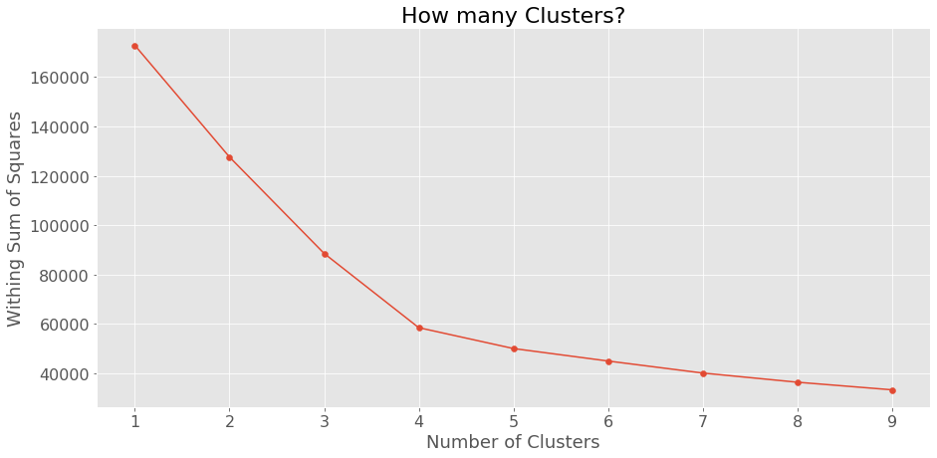

**Figure 1 – How many clusters?**

Based on the graph on the left side, there is an obvious elbow at 4 clusters. Here we can’t choose 9 clusters even though the within sum of square is the least for it. We have to choose an optimal number of clusters, choosing 9 clusters would make interpretation of the clusters difficult. So, I am choosing 4 clusters as it has balanced within sum of squares.

# **Results**

## Market Basket Analysis(MBA)

There were a plethora of association rules generated by the Apriori algorithm. I have divided them into 3 groups: Rules with high support, high confidence and high lift.

**HIGH SUPPORT**

|  |  |  |  |  |  |
| --- | --- | --- | --- | --- | --- |
| **Rule** | **Antecedent** | **Consequent** | **Support ↑** | **Confidence** | **Lift** |
| S1 | bread | cereal | 63.90 | 77.13 | 1.01 |
| S2 | banana | bread | 63.87 | 83.85 | 1.01 |
| S3 | cereal | milk | 62.22 | 81.49 | 1.00 |
| S4 | milk | banana | 62.08 | 76.32 | 1.00 |

***Table 2 Rules With High Support***

Bread & Cereal is the most popular combination of products being bought 63.9% of the time. The second and third most popular combinations of the products are Bread & Banana(63.8%) and Milk and Cereal(62.2%). These rules are also called the most obvious rules as they are the most common items bought by the customers. These rules don’t have much value to us.

**NOTE: -**  *Due to the high frequency of some products like bread, milk, cereal, banana, and lettuce, they were appearing in almost all the rules. I have decided to drop these 5 items so that I can discover the relationships between products that are not obvious.*

**HIGH CONFIDENCE**

|  |  |  |  |  |  |
| --- | --- | --- | --- | --- | --- |
| **Rule** | **Antecedent** | **Consequent** | **Support** | **Confidence↑** | **Lift** |
| C1 | (Napies, TomatoSauce) | (Baby Food) | 10.33 | 95.81 | 1.98 |
| C2 | (Olive Oil, Napies) | (Baby Food) | 10.72 | 94.26 | 1.95 |
| C3 | (coffee, householCleaners, frozenmeal) | (vegetables) | 13.75 | 93.98 | 1.61 |
| C4 | (coffee,  TomatoSauce, householCleaners) | (Vegetables) | 62.08 | 76.32 | 1.00 |

***Table 3 Rules With High Confidence***

The probabilities that Customers will buy Baby Food are 95.8% and 94.2% when they buy (Napies & TomatoSauce) and (Napies and Olive Oil). Similarly, probabilities that customers will buy Vegetables are 93.9% and 93.5% when they buy (householCleaners, frozenmeal & coffee) and (householCleaners, TomatoSauce & coffee). However, these combinations of products are less likely to occur(10% - 14%).

Rules C1 and C2 are rather strong - they both have high lift and confidence indicating that customers who buy antecedent products are 1.9 times more likely to buy the consequent products. Rules C3 and C4 are less obvious relationships. Although the lift for these rules is low, coles could probably increase sales by advertising/marketing householCleaners, coffee, frozenmeal, TomatoSauce with Vegetables(if possible stock them near).

**HIGH LIFT**

|  |  |  |  |  |  |
| --- | --- | --- | --- | --- | --- |
| **Rule** | **Antecedent** | **Consequent** | **Support** | **Confidence** | **Lift↑** |
| L1 | (fish, vegetables) | (householCleaners) | 10.82 | 85.77 | 2.24 |
| L2 | (fruit, fish) | (householCleaners) | 10.32 | 79.06 | 2.07 |
| L3 | (Napies, TomatoSauce) | (Baby Food) | 10.33 | 95.82 | 1.98 |
| L4 | (Napies, Olive Oil) | (Baby Food) | 10.72 | 94.23 | 1.95 |
| L5 | (Napies, Chocolate) | (Baby Food) | 10.69 | 92.94 | 1.92 |
| L6 | (Napies, fruit) | (Baby Food) | 14.94 | 92.85 | 1.92 |

***Table 4 Rules With High Lift***

Rule L1 - As we can see, customers who bought Vegetables & Fish are 2.2 times more likely to buy householCleaner. These items were bought together for like 10% of the time but 85% of the customers who bought Vegetables & Fish also bought householCleaners. Customers who bought fish and fruit together are 2 times more likely to but householCleaners with low support and high confidence. These products need to be marketed together or perhaps give a discount on householCleaner to the customer who buys vegetables, Fish or Fruit.

**Obvious rules – L5 & L6**

Parents often buy fruit and chocolates for their young ones. Rules L3 & L4 are not as obvious as L5 & L6 but Coles can still use them. By looking at the rules with Baby Food in consequent(with low support), We can give discounts on Baby Food if customers by (Napies & fruit), (Napies, Chocolate), (Napies, Olive Oil) or (Napies & TomatoSauce) to increase the support of these transactions[If it is not possible to carry out marketing for all the combinations, what Coles can do is it should make sure that these products are as close as possible to Baby Food].

## Clustering

After running KMeans on standardized variables z_income, z_value and z_age we get the following clusters.

|  |  |  |  |  |  |  |
| --- | --- | --- | --- | --- | --- | --- |
| **Cluster** | **Size** | **Median**  **Income** | **Median**  **Value** | **Median**  **Age** | **Homeowners**  **(Yes / No)\*** | **Sex**  **(F / M)** |
| 1 | 7.7% | $66,706 | $103 | 72 | 43% / 56% | 70% / 30% |
| 2 | 27.9% | $69,348 | $134 | 35 | 72% / 25% | 63% / 37% |
| 3 | 54.8% | $69,434 | $37 | 38 | 76% / 22% | 57% / 43% |
| 4 | 9.5% | $138,546 | $61 | 37 | 80% / 18% | 59% / 41% |

***Table 5 Cluster Features***

*[* - rest of % is for category “Unknown”]*

*[Values for variables are rounded to near integer]*

**Cluster Explanation**

1. **Cluster 1 - Elderly High Spenders**
   1. Customers in cluster 1 are **older** than customers in other clusters having a median age of **72 years** and have **low income**.
   2. Despite their low income, Customers in this cluster tend to **spend more** at the grocery store.
   3. This cluster has the **highest % of card payments** which is around **53%**.
   4. The cluster is **small in size** comprised of 7.7% of the total customers, which might be justified by saying that **old people often avoid** to **leave their house** and drive to the grocery stores. This nature of old people also **justifies their high spending**, because they **tend to buy more groceries at a time** to avoid making more trips to the store which **in turn causes fewer old people**(small size of cluster) visiting the store.
   5. Customers in cluster one have **more high number of children(>3)** compare to other clusters, which can be easily linked to their old age. In the past, people tend to have more children compared to now.
   6. The majority of the people in this cluster **do not own a house**.
   7. This cluster has the **highest % of the female customers** which is **70%**.
   8. This cluster has the **highest % of the customer owning a cat as a pet**, which is **45%**.

Basically, this cluster can be seen as **less number of people(old woman) earning high and spending more money**.

1. **Cluster 2 - High Spending Youth**
   1. Customers in cluster 2 are **younger** than customers in other clusters having a median age of **35 years** and have **low income**.
   2. Despite their low income, Customers in this cluster tend to **spend more** at the grocery store.
   3. The cluster is comprised of **28% of the total customers**.
   4. Customers in cluster 2 have **more high number of children(>3 and <9)** compare to other clusters, which can be **easily linked to their high spending**(*more children more spending*).
   5. High spending of these customers can be also justified by saying that since customers in this cluster are generally young, they might be **working professionals** and given that they are working they might **not have time to cook** things by themselves so in turn, they **buy more grocery** which probably includes **already cooked meals** which in turn **increases their spending** at the store. As they are working professional they might **not visit the store more often** and they might **buy groceries for a longer period of time** which is also one of the reasons for their high spending.
   6. **The majority** of the people in this cluster **own a house**.
   7. **Most** of the customers in this cluster are **female**.

Basically, this cluster can be seen as a **moderate number of people earning low and spending more money**.

1. **Cluster 3 – All age & Broke**
   1. Customers in cluster 3 have a median age of 38 years, the age range of 16-59 years, and have **low** **income**.
   2. Customers in cluster 3 as their income permits they spend a **low amount of money** at the store.
   3. This cluster is the **largest** **cluster** among all the clusters, comprised of 55% of the total customers.
   4. Their **low spending** and **large size of clusters** suggest that they **often visit the store** and buy **groceries** and other stuff for a **shorter period of time**.
   5. Customers in this cluster have **3 or fewer children** which also reflects their **low spending**. **Most** of the customers in this cluster have **1 child**.
   6. Customers in this cluster have the **lowest % of female customers**, which is **56%**.
   7. **Most** of the customers are **female** and they **own a house**.

Basically, this cluster can be seen as a **High number of people(of all age) earning less and spending less money**.

1. **Cluster 4 - Rich and Wise**
   1. **The median** age of the customers in this cluster is **37 years**. But Age range is **16-75 years** with 7 years of standard deviation.
   2. Customers in this cluster have **high incomes** compared to customers in the other clusters. **The median** **income** of this cluster is the **highest** among all the clusters.
   3. Even though the customers in this cluster **earn more**, they tend to **spend the moderate**(wise) amount of money at the store.
   4. This cluster is quite **small** and comprises of 10% of the customers.
   5. **Most** of the customers in this cluster **don't have a child**, which **reflects on their spending** at the store(*fewer Children - less grocery - less spending*).
   6. **Not** having **children** can be justified by saying that as they are high-income earners(more career-driven) they are working at higher level jobs(CEOs, CTOs, CFOs and so on) because of high earning.
   7. This cluster has the **highest % of cash payments** among all the clusters which is around **15%**.

Basically, this cluster can be seen as a **Low number of people(of all age) earning more and spending a moderate amount of money**.

*[Find all the cluster related graphs in Appendix]*

# **Conclusion**

* Data Quality – Coles data set raised concerns about data quality – the age, Postcode variable and the sequential invalid entries in other variables like pmethod, nchildren, homeown.
* Despite the data quality issues, it has provided great insights. The key results and recommendations are:
* Coles should put newly marketed products near the shelf of bread, milk, cereal, and banana So that customers are exposed to the new products. Coles should put these products to the end of the aisle So that customers have to walk more in the stores, in turn, they will be tempted to buy other products they see on their way to the most purchased product aisle.
* Baby Food should be displayed near the shelves of Napies, Fruit, Chocolate and Olive Oil.
* Coles could probably increase sales by advertising/marketing householCleaners, coffee, frozenmeal, TomatoSauce with Vegetables(if possible stock them near).
* Customers who bought Vegetables & Fish and Fruit and Fish are 2.2 and 2.0 times more likely to buy householCleaner respectively. Coles should spatially separate fish, vegetables, fruit, and householCleaners for greater travel distance so that customers will be encouraged to purchase other products.
* Coles should start marketing campaigns for family or house related products towards young customers(from cluster 3) as the majority of them are home owners and parents. These groups of customers are on a tighter budget and they will respond better to deals and discounts on the branded products that coles has to offer.
* On the other hand, luxury products should be targeted to customers(from cluster 1) who do not own a house and are females independent of their income and age.

# **Future Analysis**

* Recording customer’s postcode adequately would help identify patterns by states or suburbs.
* Recording data of as many customers and as many transactions as coles can by using various methods like using a points card like Flybuys. More data and correct data would help coles get meaningful insights from the data.
* Quantity of items purchased alongside the value would be more helpful in assessing customer’s preferences and spending power.
* MBA can be carried out on more generalized product categories for less-frequently purchased products, for example, put all the frozen items in one category that would increase the support of the products.

# **Appendix**

**[Red cell color suggests that data is dirty or missing in that column]**

**[Numbers in Quality of Data for one variable is independent of other variables]**

## Appendix I – Transactional variables

|  |  |  |  |
| --- | --- | --- | --- |
| **Transactional Data** | | | |
| **Variable** | **Type** | **Description** | **Quality of Data** |
| ReceiptID | Numeric - Unique Key | Unique transaction ID | 9 duplicate values |
| Value | Numeric - Continuous | Value of the transaction | No missing values, outliers detected |
| pmethod | Numeric - Categorical | Payment Method  (1 = Cash, 2 = Credit card, 3 = EftPOS, 4 = Other) | 97 erroneous entries [≈0.17%] |

## Appendix II –Demographical and Socio-Economical Features

|  |  |  |  |
| --- | --- | --- | --- |
| **Demographical & Socio-Economical Data** | | | |
| **Variable** | **Type** | **Description** | **Quality of Data** |
| sex | Numeric - Categorical- Binary | Customer’s Gender  (1 = Male, 2 = Female) | No missing values or outliers |
| homeown | Numeric - Categorical | House Ownership  (1 = Yes, 2 = No, 3 = Unknown) | 99 erroneous entries [≈0.17%] |
| income | Numeric - Continuous | Customer’s Income in dollars (Per Annum) | 1 missing value [≈ 0.0017%], Outliers detected |
| age | Numeric - Continuous | Customer’s Age | 1 missing value [≈ 0.0017%], Outliers detected |
| PostCode | String - Categorical | Customer’s Postal Code | 9792 missing values + Erroneous entries [≈17%] |
| nchildren | Numeric - Discrete | No of Children that a customer has | 2 missing value + Erroneous entries detected [≈0.19%] |

## Appendix III – Basket Items

|  |  |  |
| --- | --- | --- |
| **Basket Items** | | |
| **Variable** | **Type** | **Quality of Data** |
| fruit | String | 10 erroneous entries [≈0.017%] |
| freshmeat | Binary | No missing values or outliers |
| dairy | Binary | No missing values or outliers |
| MozerallaCheese | Binary | No missing values or outliers |
| cannedveg | Binary | 1 missing value [≈ 0.0017%] |
| cereal | Binary | 9 missing values [≈0.015%] |
| frozenmeal | Binary | No missing values or outliers |
| frozendessert | Binary | No missing values or outliers |
| pizzabase | Binary | 1 missing value [≈ 0.0017%] |
| TomatoSauce | Binary | No missing values or outliers |
| frozen fish | Binary | No missing values or outliers |
| bread | Binary | No missing values or outliers |
| milk | Binary | 1 missing value [≈0.0017%] |
| softdrink | Binary | No missing values or outliers |
| fruitjuice | Binary | 10 erroneous entries [≈0.017%] |
| confectionary | Binary | 1 missing value [≈ 0.0017%] |
| fish | Binary | No missing values or outliers |
| vegetable | Binary | No missing values or outliers |
| energydrink | Binary | No missing values or outliers |
| tea | Binary | No missing values or outliers |
| coffee | Binary | No missing values or outliers |
| laundrypowder | Binary | No missing values or outliers |
| householcleaners | Binary | No missing values or outliers |
| corn chips | Binary | No missing values or outliers |
| Frozen yogurt | Binary | No missing values or outliers |
| Chocolate | Binary | No missing values or outliers |
| Olive Oil | Binary | No missing values or outliers |
| Baby Food | Binary | No missing values or outliers |
| Napies | Binary | No missing values or outliers |
| banana | Binary | No missing values or outliers |
| cat food | Binary | No missing values or outliers |
| dog food | Binary | No missing values or outliers |
| mince | Binary | No missing values or outliers |
| Sunflower Oil | Binary | No missing values or outliers |
| chicken | Binary | No missing values or outliers |
| vitamins | Binary | No missing values or outliers |
| deodorants | Binary | No missing values or outliers |
| dishwashingliquid | Binary | No missing values or outliers |
| onions | Binary | No missing values or outliers |
| lettuce | Binary | No missing values or outliers |
| KitKat | Binary | No missing values or outliers |
| TeaTowel | Binary | No missing values or outliers |
| Scones | Binary | No missing values or outliers |

## Appendix IV – ReceiptID[Duplicates]

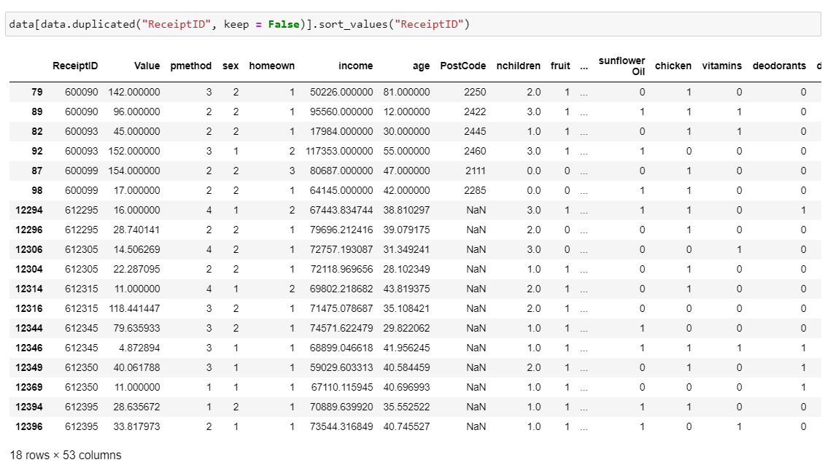

## Appendix V – Value

**Before cleaning**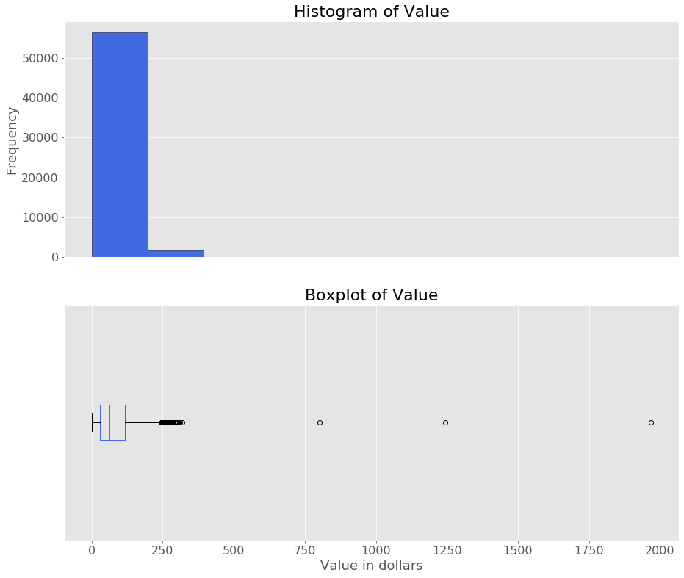

**After cleaning**

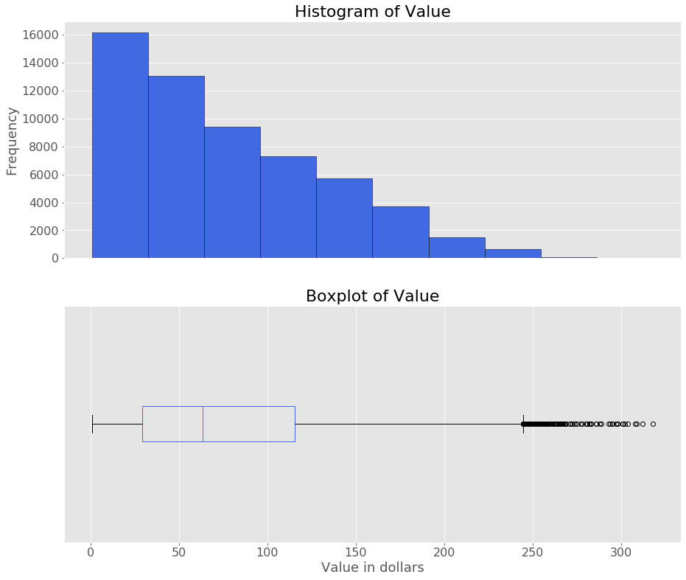

**Summary of Value Male VS Female Value**

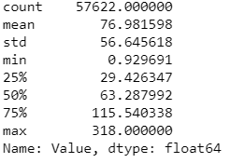 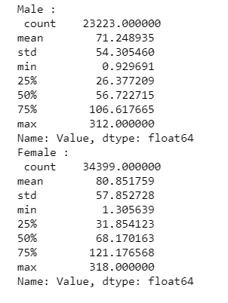

## Appendix VI – pmethod

**Before cleaning**

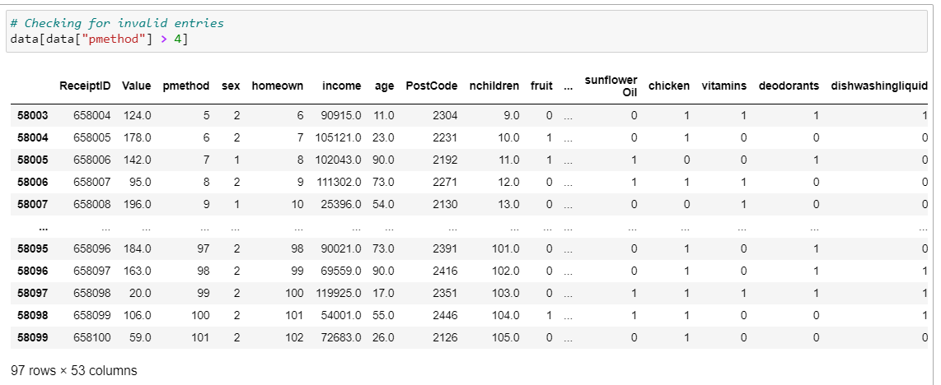

**After Cleaning**

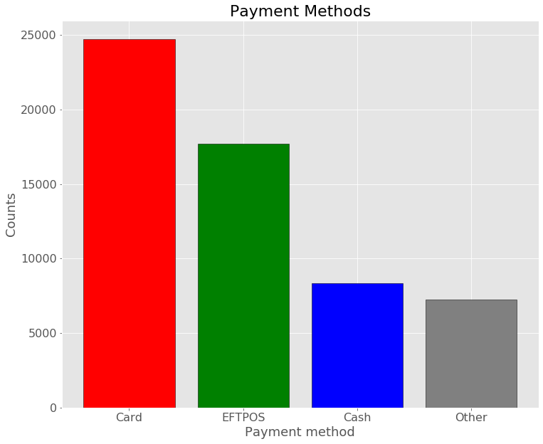

## Appendix VII – sex

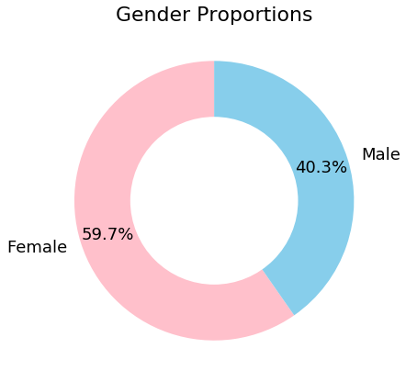

## Appendix VIII – homeown

**Before cleaning**

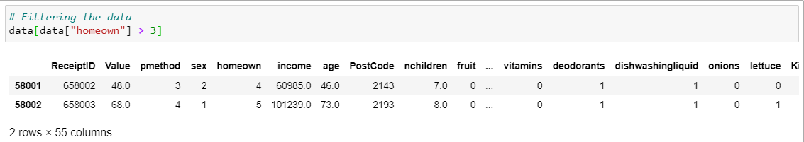

**After cleaning**

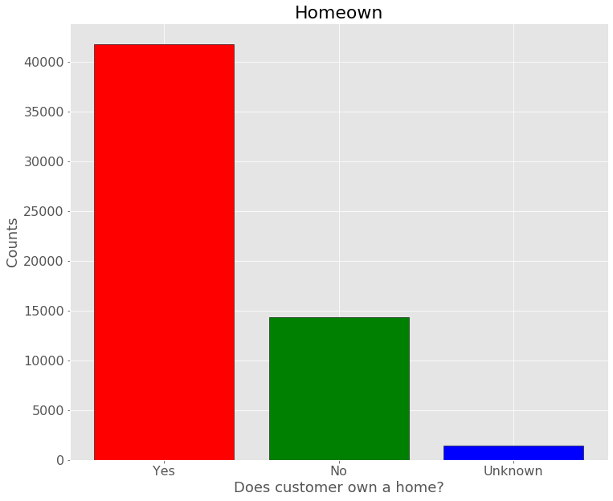

**Value for Homeowners VS Not Homeowners**

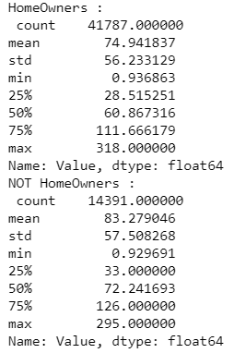

## Appendix IX – income

**Before cleaning**

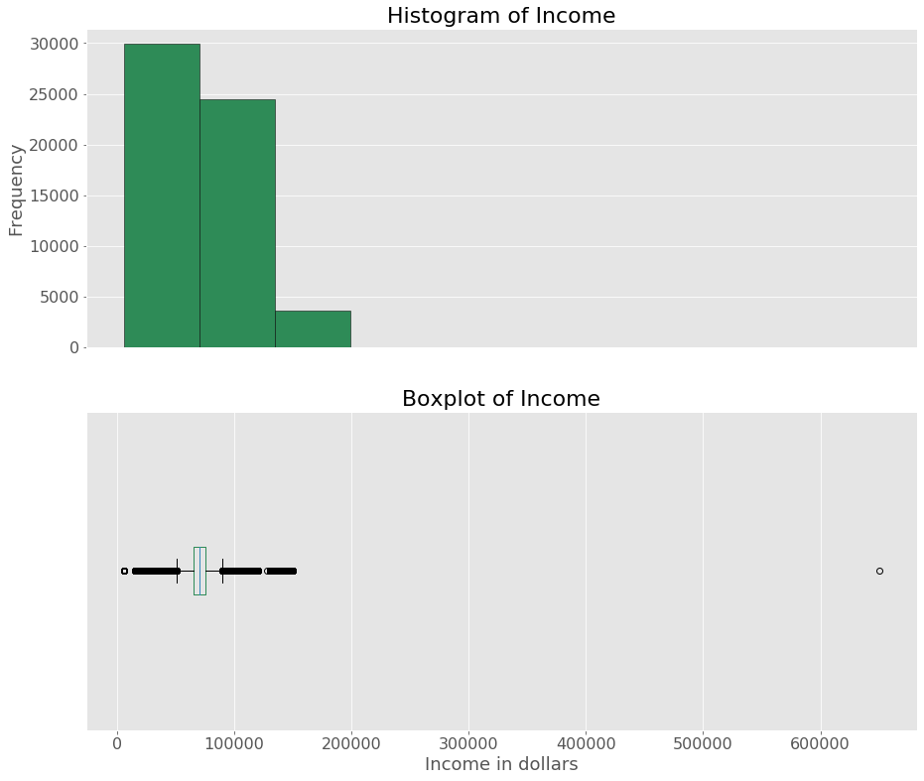

**After cleaning**

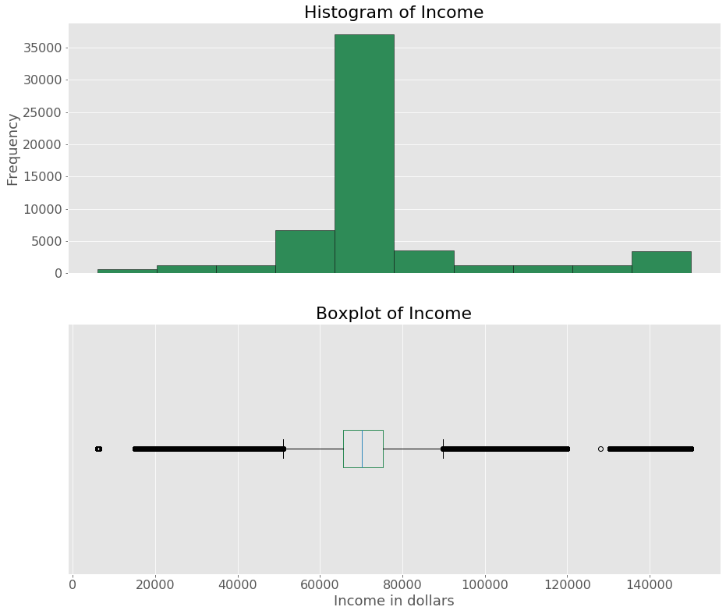

## Appendix X – age

**Before cleaning**

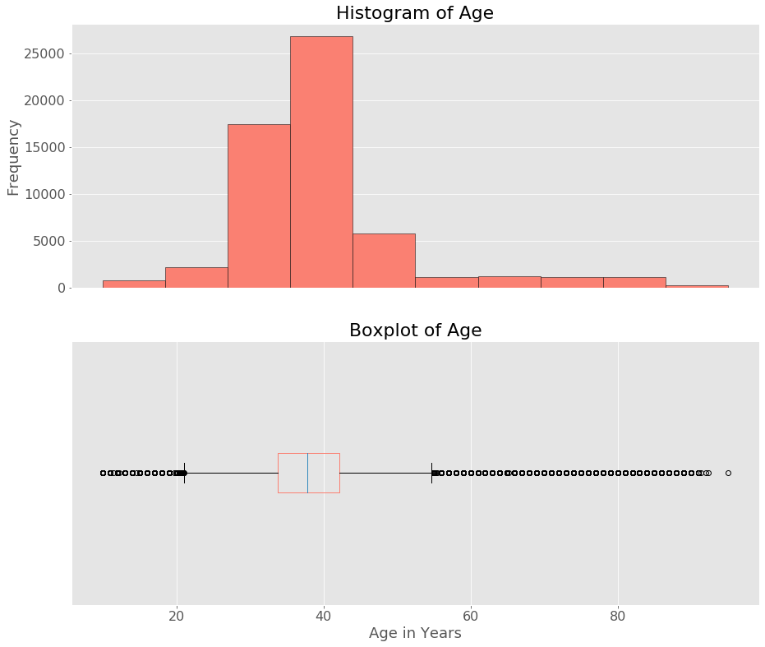

**After cleaning**

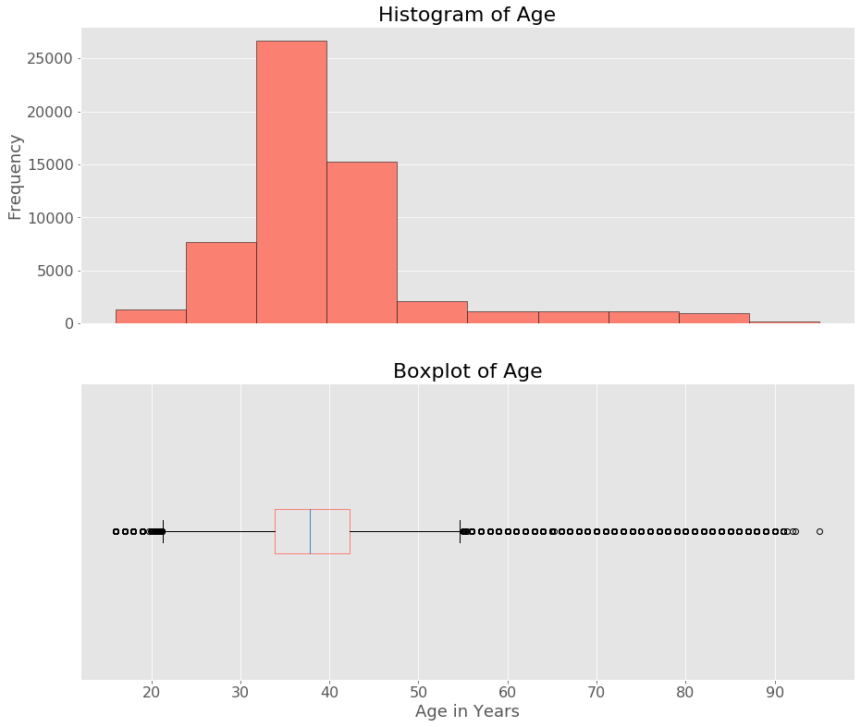

Appendix XI – nchildren

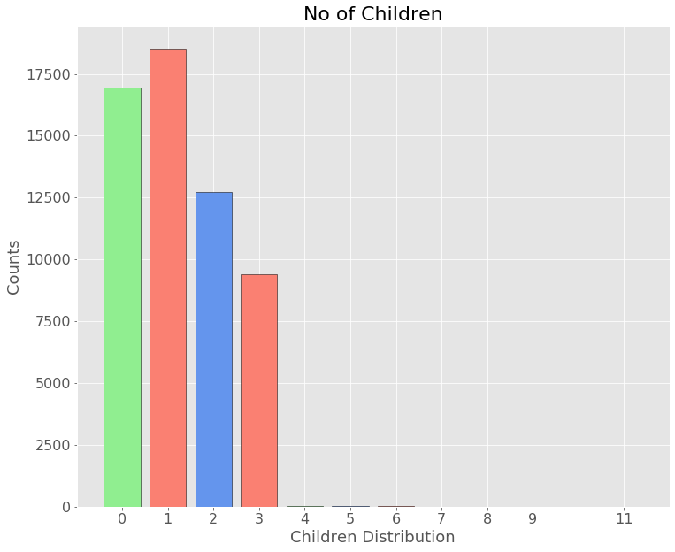

## Appendix XII – parent

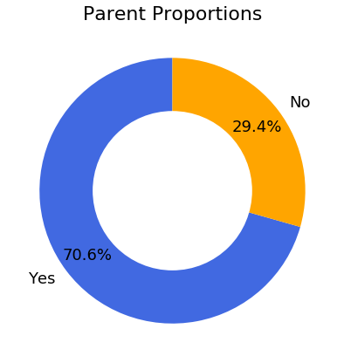

## Appendix XIII – Pet Owner

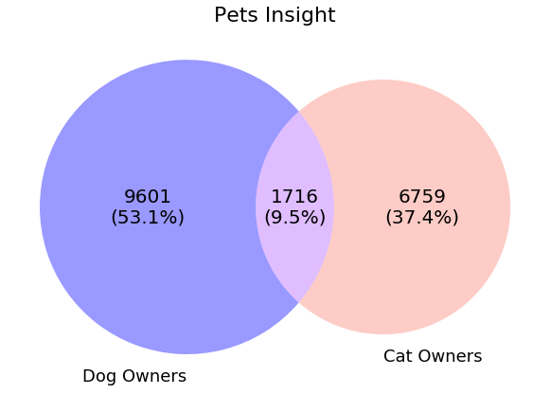

## Appendix XIV – Basket items

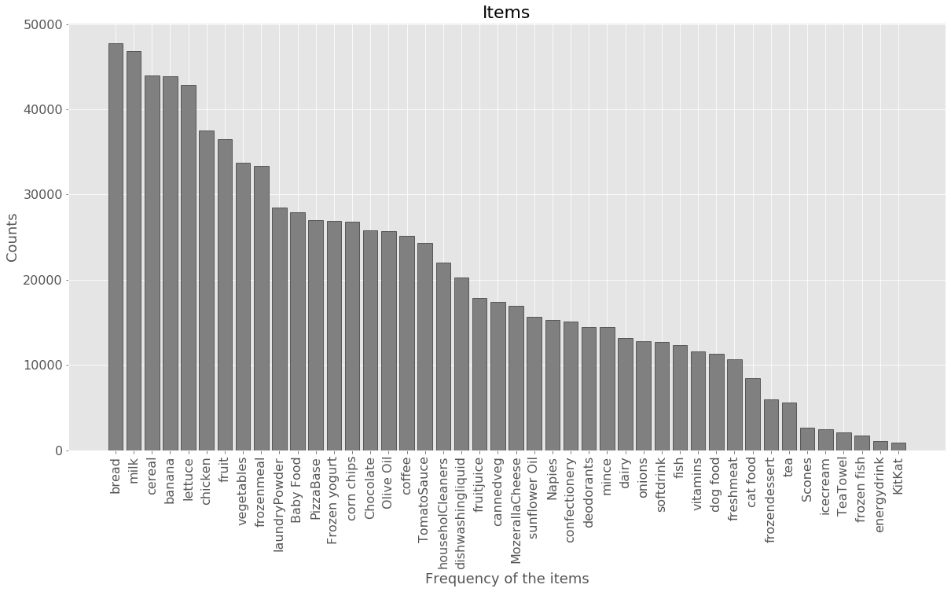

## Appendix XV – Summary for Numerical Variable

|  |  |  |  |  |  |  |  |
| --- | --- | --- | --- | --- | --- | --- | --- |
| **Variable** | **Min** | **25%** | **50%** | **75%** | **Max** | **Mean** | **Std.Dev** |
| ***Value(in $)*** | 0.92 | 29.43 | 63.29 | 115.54 | 318.00 | 76.98 | 56.64 |
| ***income(in $)*** | 6000.23 | 65,623.48 | 70,170.42 | 75324.32 | 149981.00 | 74884.04 | 23761.12 |
| ***age(in years)*** | 16 | 33.84 | 37.83 | 42.24 | 95 | 39.87 | 11.40 |

## Appendix XVI – Summary for Categorical Variable

|  |  |
| --- | --- |
| **Variable** | **Frequency – Percentage** |
| ***pmethod*** | 1 = Cash - 24,488 – 42.5%  3 = Eftpos – 17,575 – 30.5%  2= Card – 8,310 – 14.4%  4 = Other – 7,249- 12.6% |
| ***sex*** | 2 = Female – 34,399 – 59.7%  1 = Male – 23,223 – 40.3% |
| ***homeown*** | 1 = Yes – 41,787 – 72.5%  2 = No – 14,391 – 25%  3 = Unknown – 1,444 – 2.5% |
| ***parent*** | Yes – 40,683 – 70.6%  No – 16,939 – 29.4% |
| ***Pet Owner*** | No – 39,546 – 68.6%  Yes – 18,076 – 31.4% |
| ***nchildren*** | 1 = 18,519 – 32%  0 = 16,939 – 29%  2 = 12,712 – 22%  3 = 9,403 – 16%  4, 5, 6, 7, 8, 9, 11 = 49 ~= 1.1% |

## Appendix XVII – Income dominating the cluster results

1. **Income VS Value**

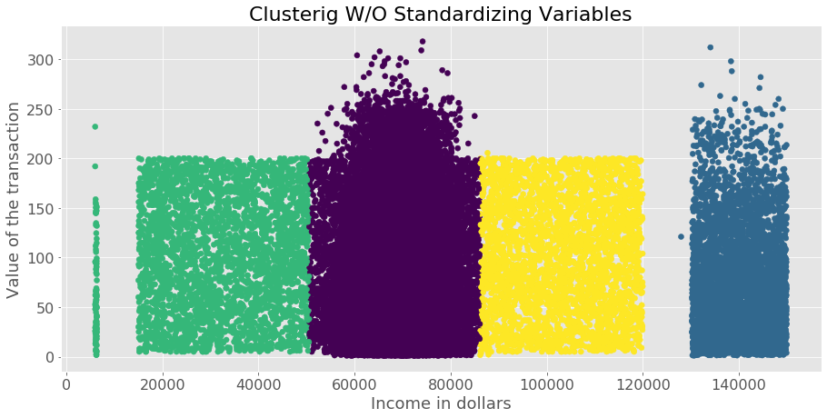

1. **Income VS Age**

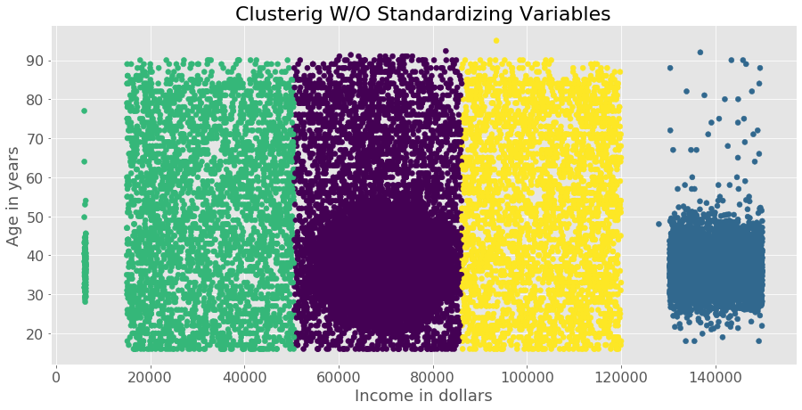

## Appendix XVIII – Cluster Size

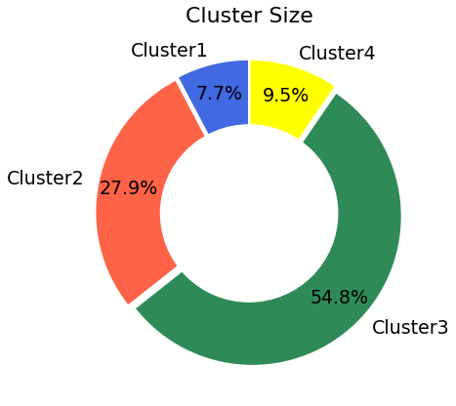

## Appendix XIX – Number of Children across clusters

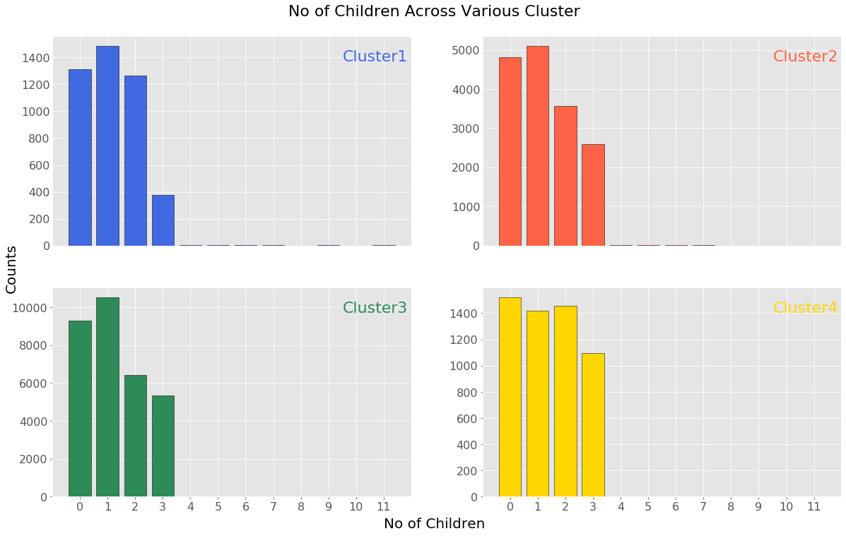

## Appendix XX – Income across clusters

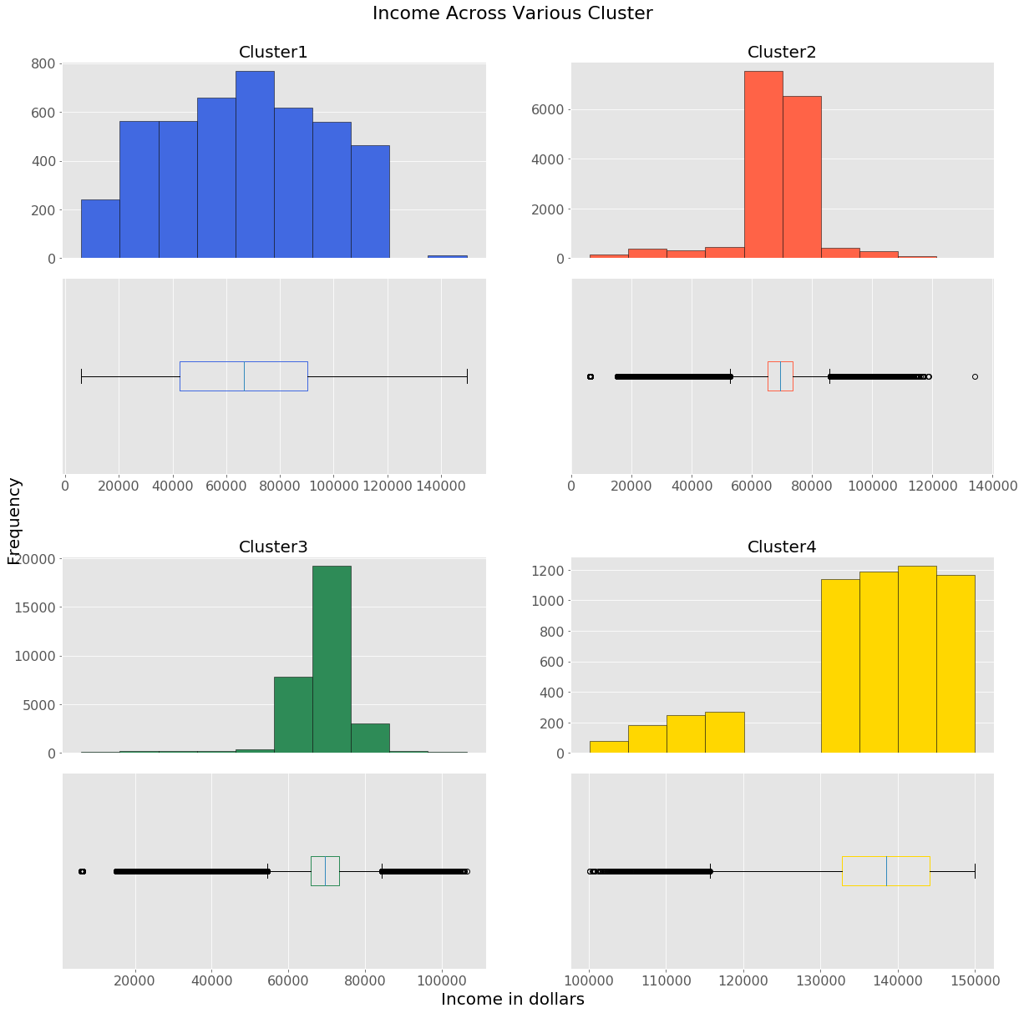

## Appendix XXI – Value across clusters

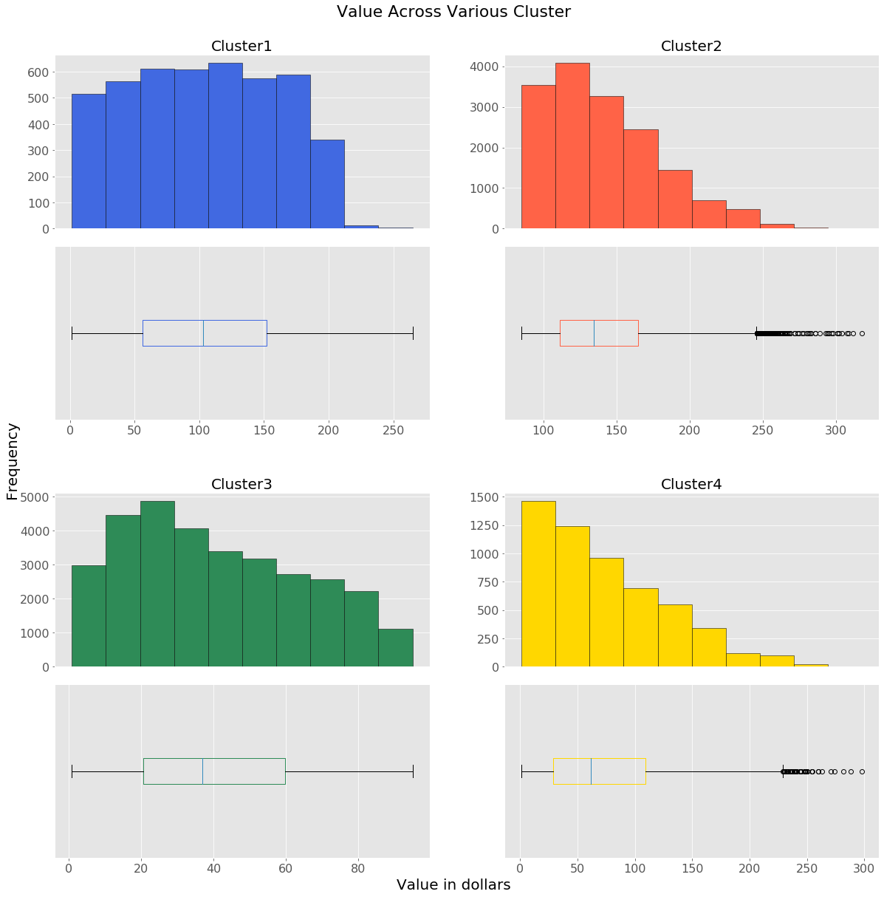

## Appendix XXII – Age across clusters

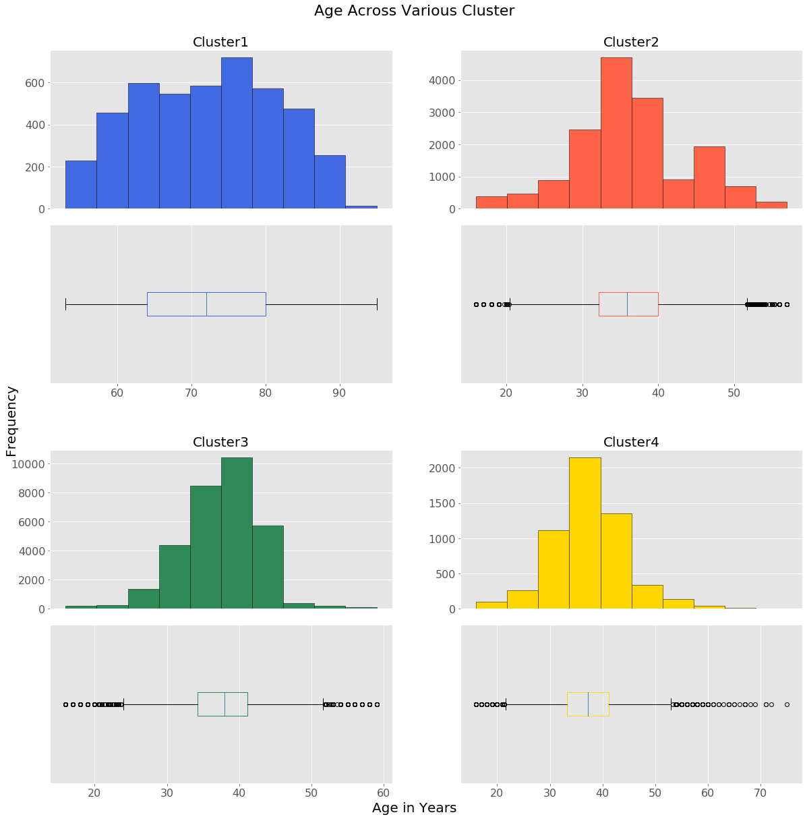

## Appendix XXIII – Gender Insights across clusters

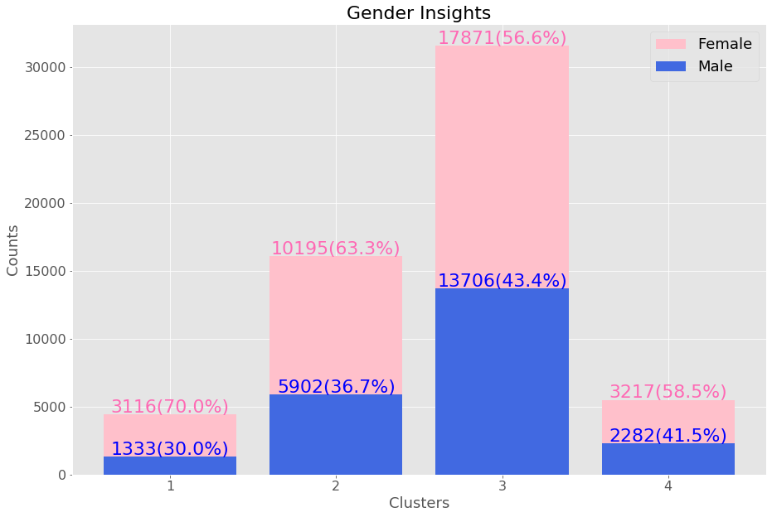

## Appendix XXIV – Payment Methods across clusters

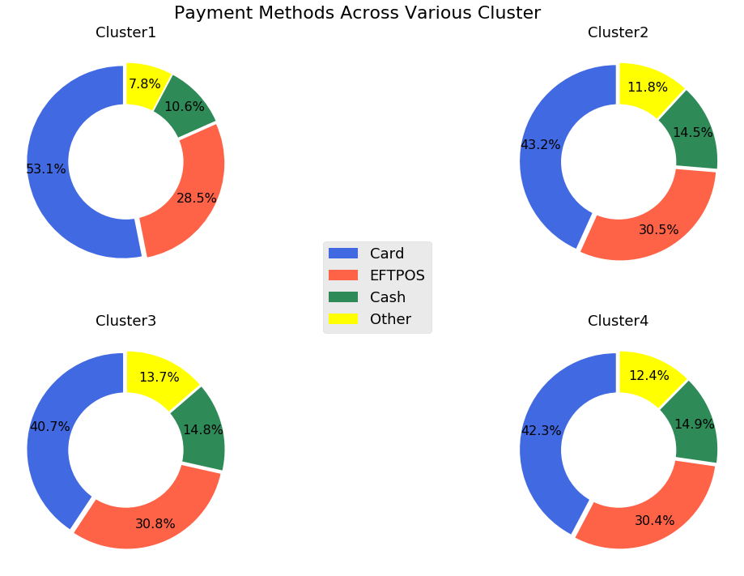

## Appendix XXV – Parents Insights across clusters

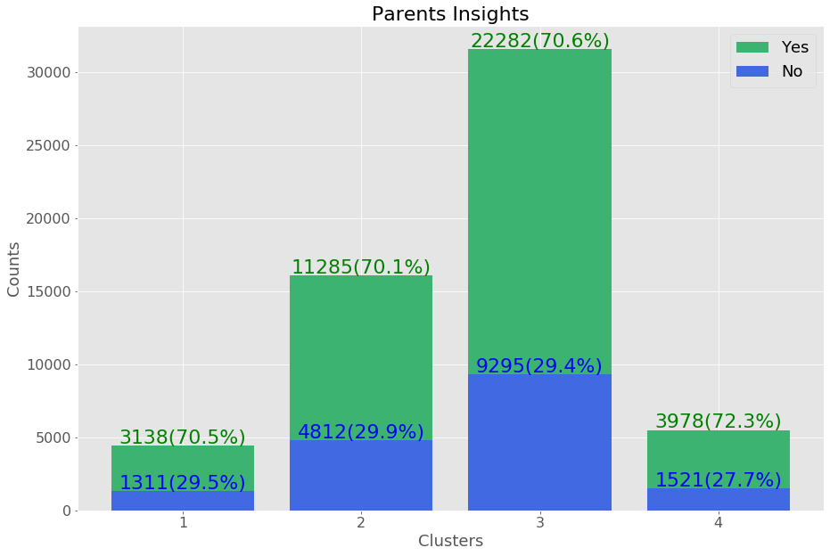

## Appendix XXVI – Homeown across clusters

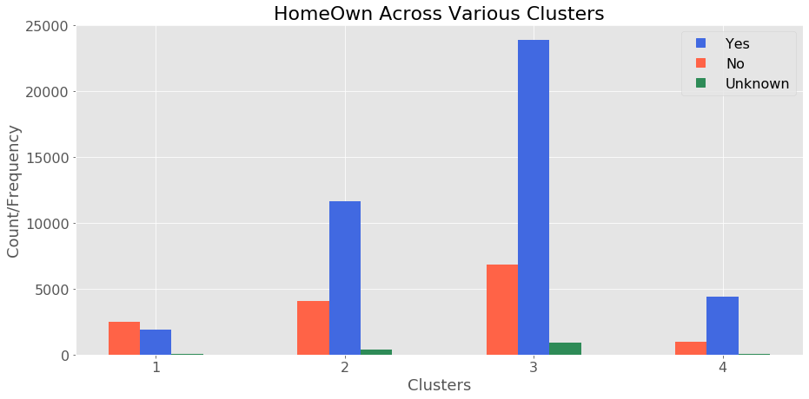

## Appendix XXVII – Pet Owner across clusters

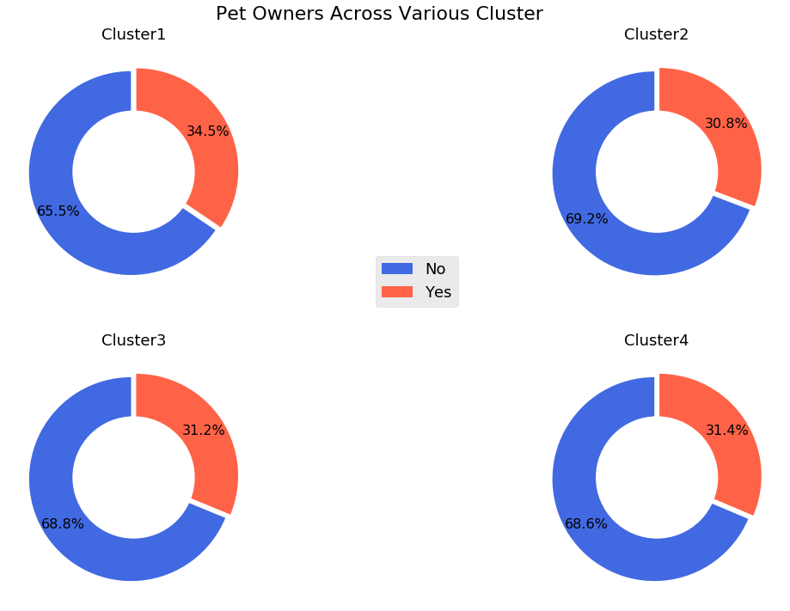

## Appendix XXVIII – Pet Insight across clusters

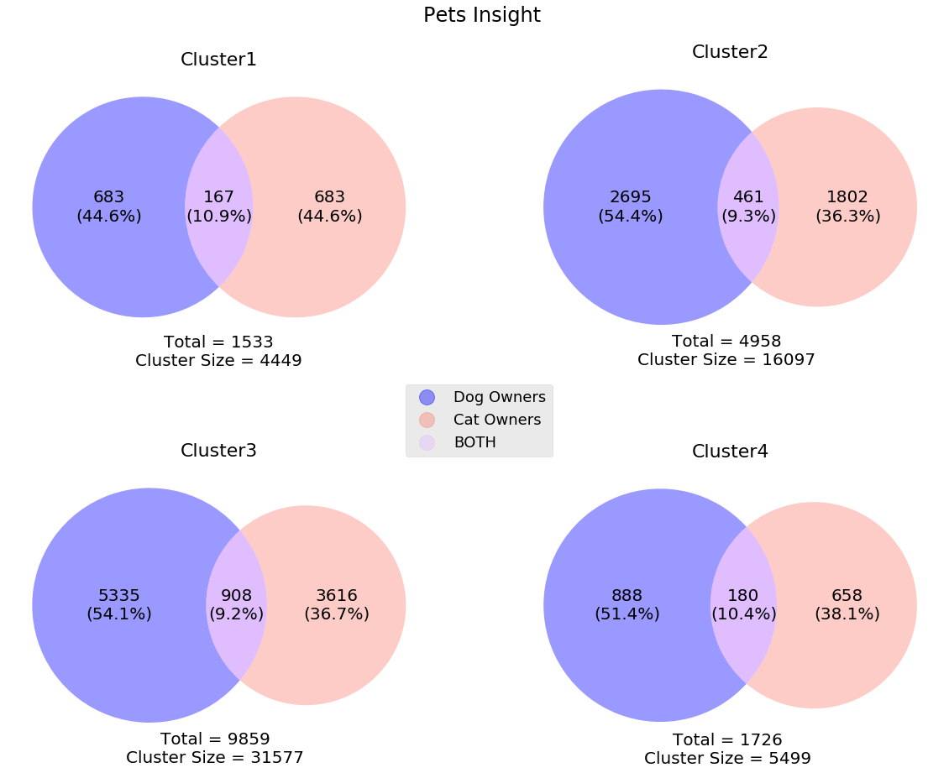

## Appendix XXIX – 3D(Income, age & Value) Scatter plot

